The Welcome Workshop

Sowaibah Hanifie
Hawke EU centre Journalism and Communications Intern
24 September 2015

The Welcome Workshop

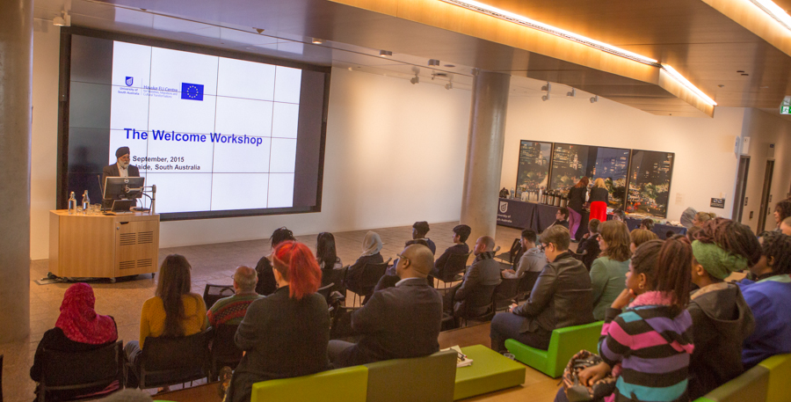

The atmosphere of the Jeffrey Smart building at the University of South Australia on the morning of The Hawke EU Centre’s Welcome Workshop event on the 16th September 2015 was filled with the emotion. As people shared their stories of arrival, others sat in silence, in awe of people’s journeys to a better life and the struggles they endured to feel welcome in their new home. The Hawke EU Centre for Mobilities, Migrations and Cultural Transformations instigated the Welcome Workshop to discuss topics of arrival, welcome and place making in an Australian context. It was designed to be a community led discussion with representatives from various organisations who would encourage questions and proposals to assist the social inclusion of new Australians. Participants included local council members from Marion and Charles Sturt, representatives from the UNESCO Network including UNESCO Chair in Transnational, Diaspora and Reconciliation Studies, Professor Pal Ahluwalia, and a variety of South Australian organisations supporting the resettlement of new Australians.

The Hawke EU centre seeks to examine the global consequences resulting from mass migration. While we see images of Syrian refugee crisis play out on our television screens, Australia has only committed to resettle 12,000 of the 6.5 million displaced asylum seekers. Professor Elliott, Executive Director of the Hawke EU Centre, opened the event by highlighting the need for us as a nation and global community to do better. Workshop convenors, Associate Professor Joanne Cys and Dr Angelique Edmonds outlined the workshop as being the first event of the Hawke UE Centre’s ‘Policy and Outreach’ work package, which aims to contribute to an international understanding of the issues related to global mobilities. Associate Professor Cys believes the notion of ‘welcome’ is fundamental to the experience of arrival involving people, place, community, creativity and inclusive activity, as well as formal aspects of support provided by local and state governments, not-for-profit support organisations and schools.

South Australian artist Peter Drew kicked off the workshop panel by sharing his most recent project with Adelaide Secondary School of English. Together with the Hawke EU centre and the school he collated the students’ artwork into a video, which illustrated their journeys to Australia and their goals for the future. Peter screened the video in different public locations around Adelaide, including the city centre, Rundle Mall. He explained when the students' work became part of public architecture, everyday people could share the experiences and emotions they felt while migrating. This can encourage empathy and compassion, which he believes are intrinsic to the expression of welcome. Peter also felt the focus in terms of refugees needed to be shifted away from the "other", and we needed to question our role of welcoming as "real Australians".

The second speaker, Dijana Karaahmetivic, a coordinator for youth services at the Australian Refugee Association reminded the audience that those who flee their homes in search of a better life are strong, resilient people. Terminology played a role in helping foster a welcome sentiment. Asylum seekers who had been accepted into Australia were to be referred to as people with a refugee "background" as their journeys to a new home were only part of their stories and this status should overshadow their entire identity. Multiculturalism may be referred to as part of an Australian identity, but Dijana argues there is still room for debate. She stated it was the responsibility of the community as a whole, including schools, families, and government to shape the future of these Australians to help them achieve the quality life they aspired for.

Australians of a migrant background are not homogenous. A person of colour is not necessarily a refugee and a Muslim woman in a hijab is not a threat to security. The third speaker Eugenia Tsoulis from the Migrant Resource Centre argued the attitude towards migrants should change to that of empowerment. Regardless of heritage, they are equals who have the potential to be positive contributors to society. She said it was time to move away from the mentality of assimilation, and begin to celebrate difference as it enriches our own culture.

When Brad Chilcott saw a young boy holding a sign that read, "sink the boats" during the Inverbrackie detention centre protests in 2010, he wondered how we, as a society, had gotten to the point where such words were socially acceptable. Brad was the fourth panel speaker and founder of Welcome To Australia, an organisation which hopes to cultivate a culture of welcome. A key aim for the centre is to invade public space, which is often washed with fear politics, by reinforcing respect and tolerance.
The final panellist, City of Charles Sturt mayor, Angela Keneally, said the council was working on ideas to engage diverse community in place making projects like those referred to by Peter and Brad. She elaborated that place-making builds civic pride by giving individuals ownership of public space and establishing them as a home and place of love.

"You don't change someone's heart with policies and facts. You change someone's heart through relationships," Brad Chilcott's words echoed through the breakaway group sessions as part of the workshops program. When audience members were placed into smaller groups, stories were told and journeys reflected on. Each group was to suggest how we were to generate a sense of welcome in the future then present their ideas to the entire workshop. It was during this time the most crucial elements of belonging were acknowledged. Each person had their own story to tell, their own experiences of arrival and exclusion. It was a room filled with emotion as the struggles of migration and integration had become ever more real. Through these sessions, ideas to achieve a vision of Australia that resonated with the values of fair go and multiculturalism were generated.

The Welcome Workshop initiated thought provoking questions such as what does welcome mean? And how is a sense of welcome achieved? It allowed stakeholders from various bodies and industries to begin unpacking dichotomies of multiculturalism and interculturality that exist in our society. The concluding suggestions and statements from the participants were that "welcome" was not only a word with connotations of tolerance, but it was an impassioned term that needed to be demonstrated through our actions. Many refugees and migrants come to Australia, having little or no knowledge of English. They need to be empowered by gaining linguistic mobility, which can pave the way to future employment and independence. Although welfare is essential, the challenge is to assist migrants achieve such independence through skills training. To welcome means to move past our fears of difference and escape our comfort zones. It means to allow freedom of choice and freedom to practice traditions of back home.

Reflecting on the workshop, Associate Professor Cys said, "It was very important for each guest to gain an understanding of the differing experiences and meanings of ‘welcome’ depending on the perspective of the person being welcomed and the person/people/organisation providing the welcome." Improvement is a never-ending process fuelled by discussion, reflection and interpretation. The themes, issues and challenges recognized from the workshop would inform the approach for upcoming EU Centre events to stimulate conversation, so we as a community can continue to progress forward.

