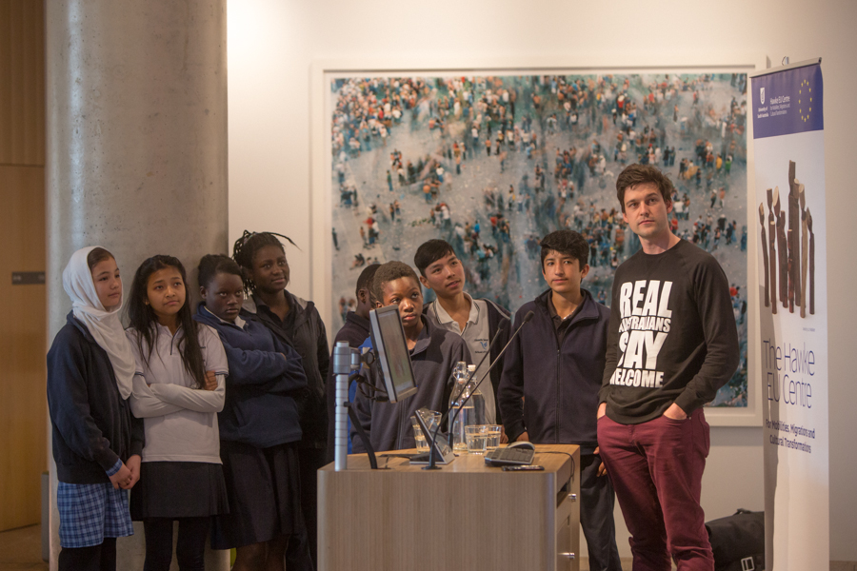

Peter Drew and Adelaide Secondary School of English student at the Hawke EU Centre Welcome Workshop, Jeffrey Smart Building, UniSA September 2015.

The Man Behind the Posters, Peter Drew

- Sowaibah Hanifie
Hawke EU Centre Journalism and Communications Intern
24 September 2015

- South Australian artist Peter Drew believes Australia was once a welcoming place. This was until Australians allowed the politics of fear to overpower our emotions. Peter's most recent project, in association with The Hawke EU Centre, was a video compilation of artwork created by the students of Adelaide Secondary School of English (ASSOE), many of whom come from a refugee or migrant background. As part of the video, students share their journeys of migration and arrival to Australia, and their goals for the future. The video was played in various public spaces, empowering the students to envision how their stories could change society.

- "I asked them to tell stories about where they come from, why they left, how they got to Australia and where they would like to be in the future," Peter explained.

- The video begins with the words "my story, my city." The Adelaide Secondary students are seen digitally projecting their drawings onto public landscapes, symbolizing their claim of the city as their home. A young boy's voicer over explains how his family’s migration from Afghanistan was for him to have a better future. Another student shares her aspirations to become a nurse. She says she would like to go back to Africa and treat her people who are suffering from Ebola and other diseases. Her classmate continues on with his dream of becoming a policeman, of wanting to protect people and help the poor. Moments later he explains due to of the conflict between police and civilians back home, he does not have a family.

- For Peter, to hear and meet these children who had gone through such painful experiences was something he was not prepared for. When living a life of comfort in a peaceful home like Australia, it can be difficult to sympathise with a young child who had not experienced a day of stability before migration.

- "There were some stories that were quiet harrowing, it seemed sort of normalised for them, they were comfortable talking about things in a matter of fact way. It was something I wasn't used to," he said.

For many others who are accustomed to the luxury of peace and stability, the idea of struggling for survival and being forced to leave their home is foreign. The challenge for Peter was to open their eyes and hearts, and to hear the stories of these young souls. To understand their struggles, so they could find the empathy to extend a hand of welcome.

- "It's difficult trying to establish empathy with the wider community. Children are less threatening... so to hear their stories, and how ‘normal’ they are, is a powerful thing. People like myself who are born and raised in Australia can see how we can better that dialogue"

- Improving dialogue through art is a talent Peter is globally recognised for. His last venture, Real Australian's Say Welcome exposed and questioned our natural of fear of difference. As part of the project Peter plaster 1000 posters all across Australia with the statement "Real Australians Say Welcome". The public were also encouraged to take ownership of the slogan and ensure it was heard.
- The campaign video for the project highlighted the Australian national anthem's verses: "For those who have come across the seas; We've boundless plains to share; With courage let us all combine; To advance Australia fair". These lines were significant for Peter, as he believed they drew out the "greatest thing about being Australian". Hence the underlying message for the project was to encourage people to understand the ability to say "welcome" as an act of courage. Fear is a natural response to the unknown, however as Peter believes, overcoming this anxiety and showing compassion is an inspiring act of strength.

- Further, Peter's work with the “Real Australians say Welcomes” posters seeks to question whether or not we as a society had the courage to combine and embrace difference.

- By using the terms "real Australians" he wishes to reform the idea of nationalism, which is often associated with inclusion and exclusion dichotomies. Alternatively Peter wishes for Nationalism to be centred on a more positive sense of pride and tolerance –

an ability to say welcome seen as a fundamental part of being “an Aussie”.

- "My intention was first to get people who considered themselves to be real Australians to stop and consider what it feels like to be excluded from that group," Peter said.

- Most importantly, the artwork is geared toward provoking public discussion about the treatment of asylum seekers. And while it may not have lead to direct revolution of policies, Peter says it has made changes in ways he had not anticipated.

- "What I didn’t expect and what was perhaps the most rewarding thing for me, was the responses and messages I got from asylum seekers themselves who are in Australia on bridging visas and feeling alienated."

- "It made me realise the whole other audience for the project I hadn't considered. And that by doing simple acts of welcome, everyday Australians can, in their everyday lives, can make a change for the better..."

- To see Peter Drew's Work, visit http://www.peterdrewarts.com

