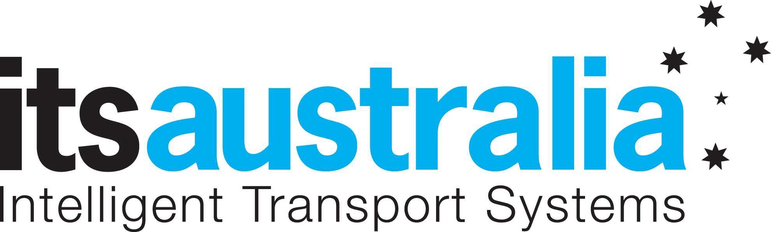

Media Release

ITS Australia announces Mobility as a Service Research Project

Melbourne 21 March 2018 Intelligent Transport Systems Australia (ITS Australia), the peak body for the intelligent transport systems industry in Australia, together with the iMOVE CRC, has today announced a project to better understand what Mobility as a Service means for Australia and, importantly, what Australians think.

Mobility as a Service (MaaS) is the integration of multiple modes of transport into a single, inter- modal travel service, accessible on demand. The fundamental point of MaaS is to put the users at the centre of transport and mobility options, with accurate and real-time information about modes, routes, and service availability, including public transport, ride-sharing, bikes, and walking and parking, helping travellers get to where they want to go more easily. A full MaaS ecosystem can offer people real choice and improve mobility outcomes for them as individuals all based on their individual needs, handling everything from accessibility needs, special requests and payments.

MaaS also offers business models and platforms with advantages for transport operators including access to improved user and demand information, and opportunities to serve unmet or latent demand. The aim of MaaS is to provide an alternative to the use of the private car that may be as convenient, more sustainable, help to reduce congestion and constraints in transport capacity, and importantly provide better mobility options for communities at an adaptable price.1

ITS Australia, through the iMOVE CRC, are partnering with the Institute for Choice (University of South Australia), and leading transport stakeholders; Transport for Victoria, Transport for NSW, Translink, Department of Transport WA and Royal Automobile Association SA, and developing a MaaS consumer research report asking the question; What does MaaS mean for Australia, and what do Australians think?

Dr. Joffre Swait, research co-director at the Institute for Choice (I4C), said at a recent project working meeting that "MaaS promises to be an exciting new paradigm for the provision of

transport services. I4C is delighted to be collaborating with partners in industry and government to help understand Australian consumers' expectations and preferences for MaaS."

To maximise the benefits of MaaS for Australia, there needs to be a well-planned and collaborative approach. To that end we have developed a consumer survey to be taken by thousands of Australians nationwide. This survey is supported by an exhaustive literature review and analysis of existing mobility services that fit the MaaS description, as well as interviews with leading transport professionals from the public and private sectors.

Ian Christensen, Managing Director, iMOVE Australia said “A successful transport system encompasses many forms of getting around, often mixing several different transport modes. It is crucial to understand the drivers for choice of mode in order to deliver options that work for transport users. iMOVE is pleased to support this MaaS project that will provide important consumer and industry perspectives to help shape the MaaS element of the overall transport landscape for Australia”.

Susan Harris, CEO, ITS Australia added “The research and survey responses will be analysed to glean insights into how Australia can prepare a pathway forward for these mobility services locally. Looking at a holistic approach that ensures our most important stakeholders, end-users or customers are included in preparing for this exciting once-in-a-generation opportunity.”

Susan Harris will present the initial findings of the national consumer research and report project at the Mobility as a Service (MaaS) Conference in Sydney, 3 May 2018 – the inaugural MaaS conference for ITS Australia. The complete report will be published and presented to the industry in early June.

ENDS

1 Reference http://maasaustralia.com/ and https://maas-alliance.eu/homepage/what-is-maas/

For interviews and further information:

Kathryn Belton Communications Manager ITS Australia
+61 412 116 290
kathryn.belton@its-australia.com.au
Jacqueline King Communications Manager iMOVE Australia
+61 404 045 293
jking@imovecrc.com
Dr Akshay Vij
Senior Research Fellow Institute for Choice
+61 8 8302 0817
akshay.vij@unisa.edu.au

About ITS Australia
Intelligent Transport Systems Australia (ITS Australia) promotes the development and deployment of advanced technologies to deliver safer, more efficient and environmentally sustainable transport across all public and private modes – air, sea, road and rail. Established in 1992, ITS Australia advocates the application of communication, data processing and electronic technologies for in-vehicle, vehicle-to-vehicle, vehicle-to-infrastructure and mode-to-mode systems to increase transport safety and sustainability, reduce congestion, and improve the performance and competitiveness of Australia’s networks. ITS Australia is an independent not-for-profit incorporated membership organisation representing ITS suppliers, government authorities, academia and transport businesses and users. Affiliated with peak ITS organisations around the world, ITS Australia is a major international contributor to the development of the industry and host of the 2001 and 2016 ITS World Congress.

About iMove Australia
iMOVE is the national Australian centre for R&D in intelligent transport. It is jointly funded by the Australian federal government’s Cooperative Research Centre Programme and industry. Formed in July 2017, it has 44 industry, government and research partners, including the federal departments of Industry, Innovation and Science and Infrastructure, Regional Development and Cities, state road authorities, retailers, logistics and insurance companies, technology developers, automobile clubs and many of Australia’s top universities. The ten-year centre is undertaking industry-led research that uses emerging technologies to improve Australian transport systems. It will deliver globally relevant solutions that enhance mobility on the roads and public transport and provide fast and predictable freight services.

About the Institute for Choice
The Institute for Choice (I4C) brings together a global, multi-disciplinary team of choice modellers to ensure our clients only receive cutting-edge, robust research. Choice modelling is the science of understanding how people make choices and why. Three decades of research have shown that choice modelling produces accurate estimates of individual and group choice behaviour, as well as willingness to pay for market and non-market goods. We are a Sydney-based academic research institute, part of the University of South Australia (UniSA) employing experts in a range of applied economics fields,
including behavioural, health, environmental, and transport economics. I4C is unique in our ability to blend the realism of behavioural economics with the empirical robustness of choice modelling.

